SIMATS ENGINEERING
ASSESSMENT TOOL 2

COURSE NAME: Cryptography and Network Security
COURSE CODE: CSA51

COURSE OUTCOME COVERED

CO1: Apply classical encryption techniques using symmetric and asymmetric ciphers to encrypt and decrypt data for the ensuring data security. (BL3, BL4)

Assessment Tool Weightage: 20%

QUESTIONS: 5 Total Marks:50

Annexure A

CONCEPT MAPPING

Code of Conduct:

I Preethika M certify that this submission is my original work and that I have adhered to the guidelines specified for this assessment.
I understand that any violation of academic integrity rules will result in disciplinary action.

Signature of the student:
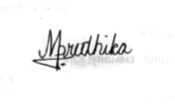

Annexure A

CONCEPT MAPPING

1. Create a concept map linking the following: Security Attacks, Threats, Risks and Security Goals (Confidentiality, Integrity, Availability. Perform the following tasks:
- Show how each attack leads to specific threats and risks
- Map how security goals help mitigate them Provide one real-world example for each link

2. Develop a concept map comparing substitution techniques: Caesar Cipher, Monoalphabetic Cipher, Vigenère Cipher and Hill Cipher. Perform the following tasks to connect based on: Key usage, Complexity and Security strength. Analyze which technique is most secure and why.

3. Construct a concept map for Classical Encryption Schemes: Substitution Techniques and Transposition Techniques. Perform the following tasks:
- Show differences and similarities
i.Map how each affects the Data structure and Security level
ii.Analyze which is more vulnerable to attacks and why

4. Create a concept map connecting Steganography concepts: Data Hiding, Watermarking and Survivability. Perform the following tasks:
- Show relationships between these concepts
- Analyze how each contributes to secure communication
- Include one real-world application for each

5. Draw a concept map linking number theory concepts used in cryptography:
Modular Inverse, Extended Euclid Algorithm, Fermat’s Little Theorem, Euler’s Phi Function and Euler’s Theorem. Perform the following tasks:
- Show how each concept is mathematically connected
- Map their role in encryption/decryption
- Analyze which concept is most critical for public key cryptography and justify

ANSWERS TO CONCEPT MAPPING QUESTIONS

Question 1: Security Attacks, Threats, Risks and Security Goals

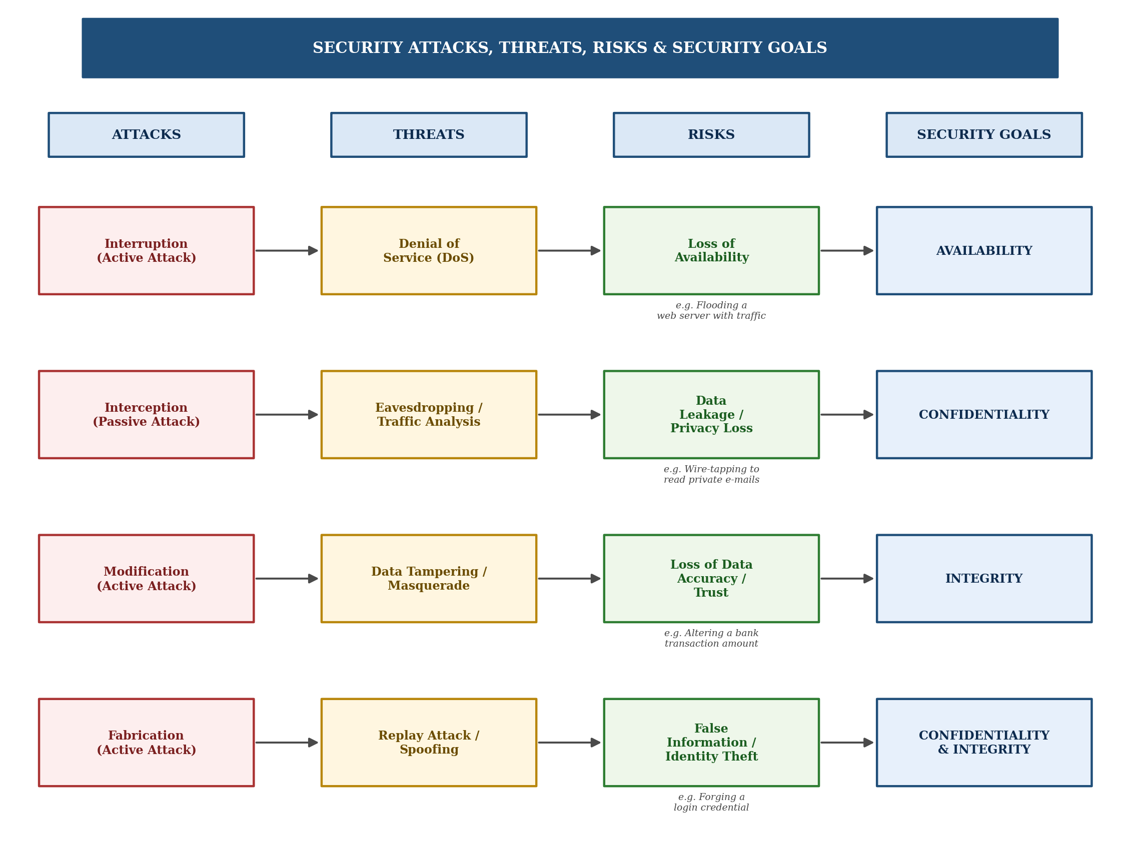

Explanation: A security attack is any action that compromises the safety of information. Passive attacks such as interception lead to threats like eavesdropping and traffic analysis, creating the risk of data leakage without the victim's knowledge. Active attacks such as interruption, modification and fabrication generate threats like denial of service, data tampering and replay/spoofing, which in turn create risks ranging from loss of availability to identity theft. Each of these risks is mitigated by one or more of the three core security goals - Confidentiality, Integrity and Availability (the CIA triad). For instance, encrypting network traffic preserves confidentiality against eavesdropping, while checksums and digital signatures preserve integrity against tampering, and redundant servers preserve availability against denial-of-service attacks. Mapping attacks through threats and risks to the goal that counters them shows why the CIA triad is the foundation of every practical security design.

Question 2: Comparison of Substitution Ciphers

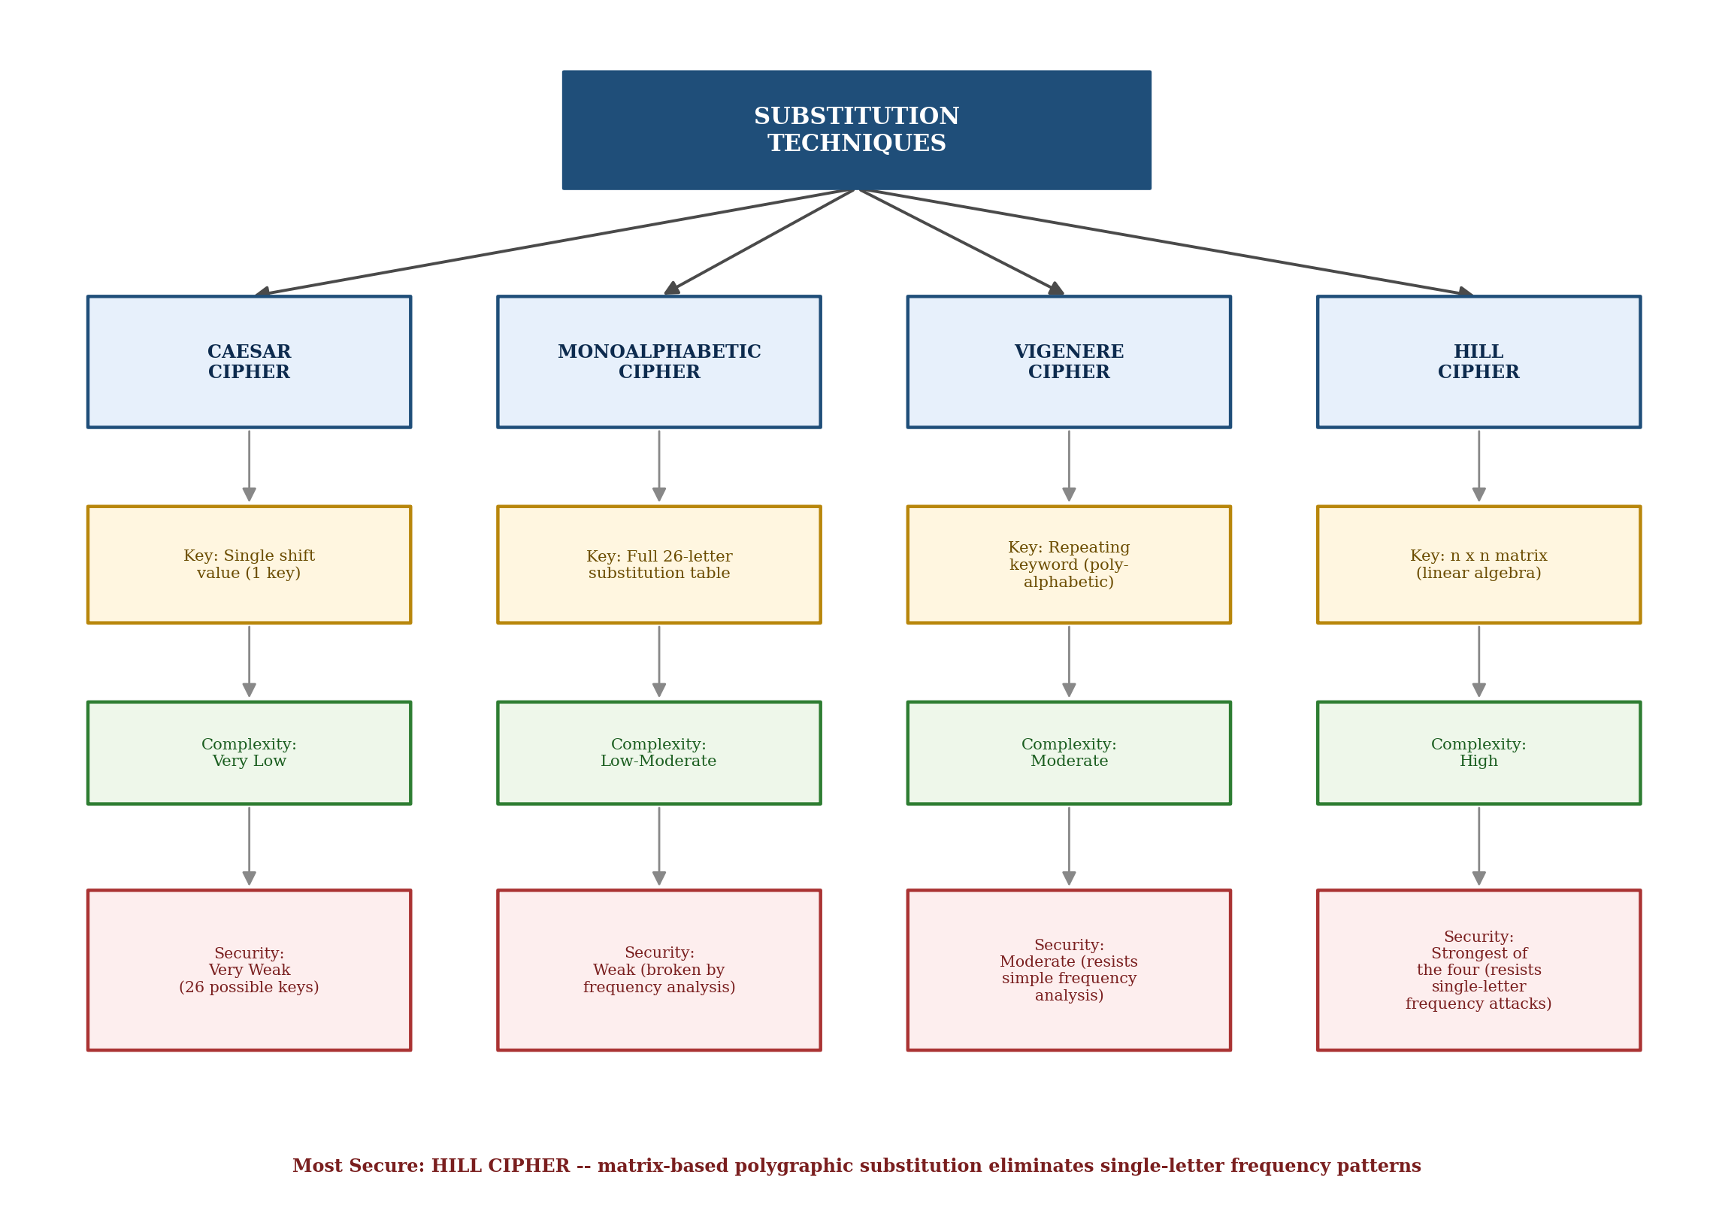

Comparison Table
Cipher | Key Usage | Complexity | Security Strength
Caesar Cipher | Single fixed shift value (1 key, 25 possibilities) | Very Low | Very Weak - trivially brute-forced
Monoalphabetic Cipher | Full random 26-letter substitution table | Low to Moderate | Weak - broken by letter-frequency analysis
Vigenere Cipher | Repeating keyword; polyalphabetic shifts | Moderate | Moderate - resists simple frequency analysis but vulnerable to Kasiski examination
Hill Cipher | n x n invertible matrix over modulo arithmetic | High | Strongest of the four - encrypts blocks of letters together, masking single-letter frequencies

Analysis: Among the four substitution ciphers, the Hill Cipher is the most secure. Because it encrypts blocks of letters simultaneously using matrix multiplication rather than substituting one letter at a time, it destroys the single-letter frequency patterns that make the Caesar, Monoalphabetic and even Vigenere ciphers vulnerable to statistical cryptanalysis. Its main weakness is a known-plaintext attack using linear algebra, but purely from a classical, ciphertext-only standpoint, it is the strongest of the four.

Question 3: Substitution vs Transposition Techniques

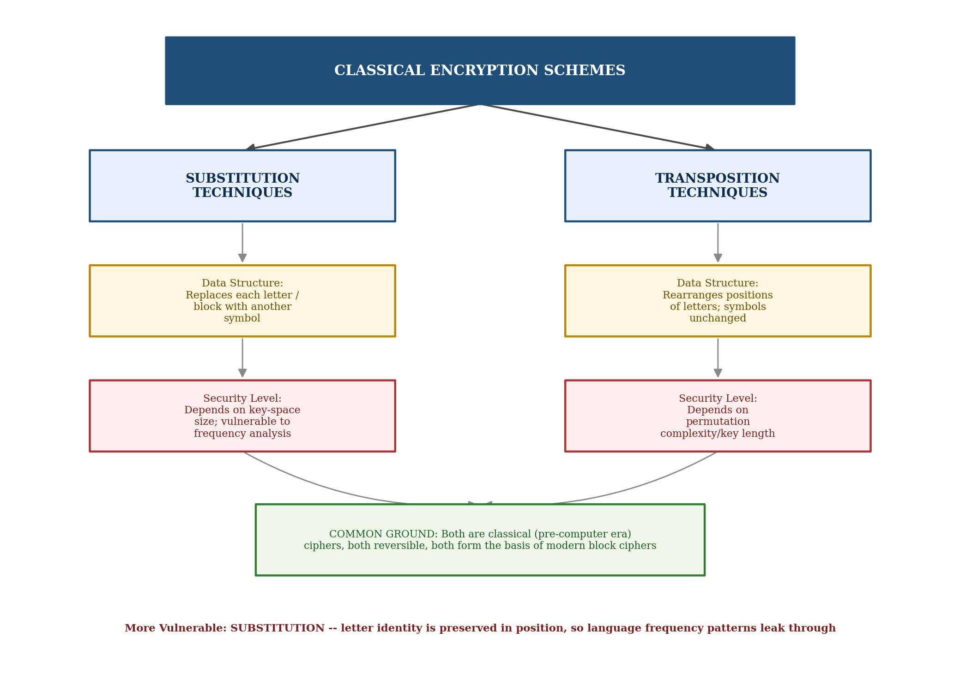

Comparison Table
Aspect | Substitution Techniques | Transposition Techniques
Basic Principle | Replaces each plaintext symbol with a different symbol | Rearranges the positions of plaintext symbols without changing them
Effect on Data Structure | Changes the identity of characters; sequence order unchanged | Changes the sequence/order of characters; identity unchanged
Security Level | Depends on the size of the substitution key space | Depends on the complexity of the permutation pattern
Example | Caesar Cipher, Vigenere Cipher | Rail Fence Cipher, Columnar Transposition

Analysis and Conclusion: Substitution and transposition are the two fundamental building blocks of classical cryptography, and modern block ciphers (such as DES and AES) combine both principles through repeated rounds of substitution and permutation. Of the two, substitution techniques are generally more vulnerable to attack because the identity of each symbol is preserved somewhere in the ciphertext, allowing frequency analysis to reveal the underlying language patterns. Transposition techniques preserve the letters themselves, so simple frequency counts remain unchanged and cannot immediately reveal the key, though they too can be broken with enough ciphertext through anagramming and pattern analysis.

Question 4: Steganography, Data Hiding, Watermarking and Survivability

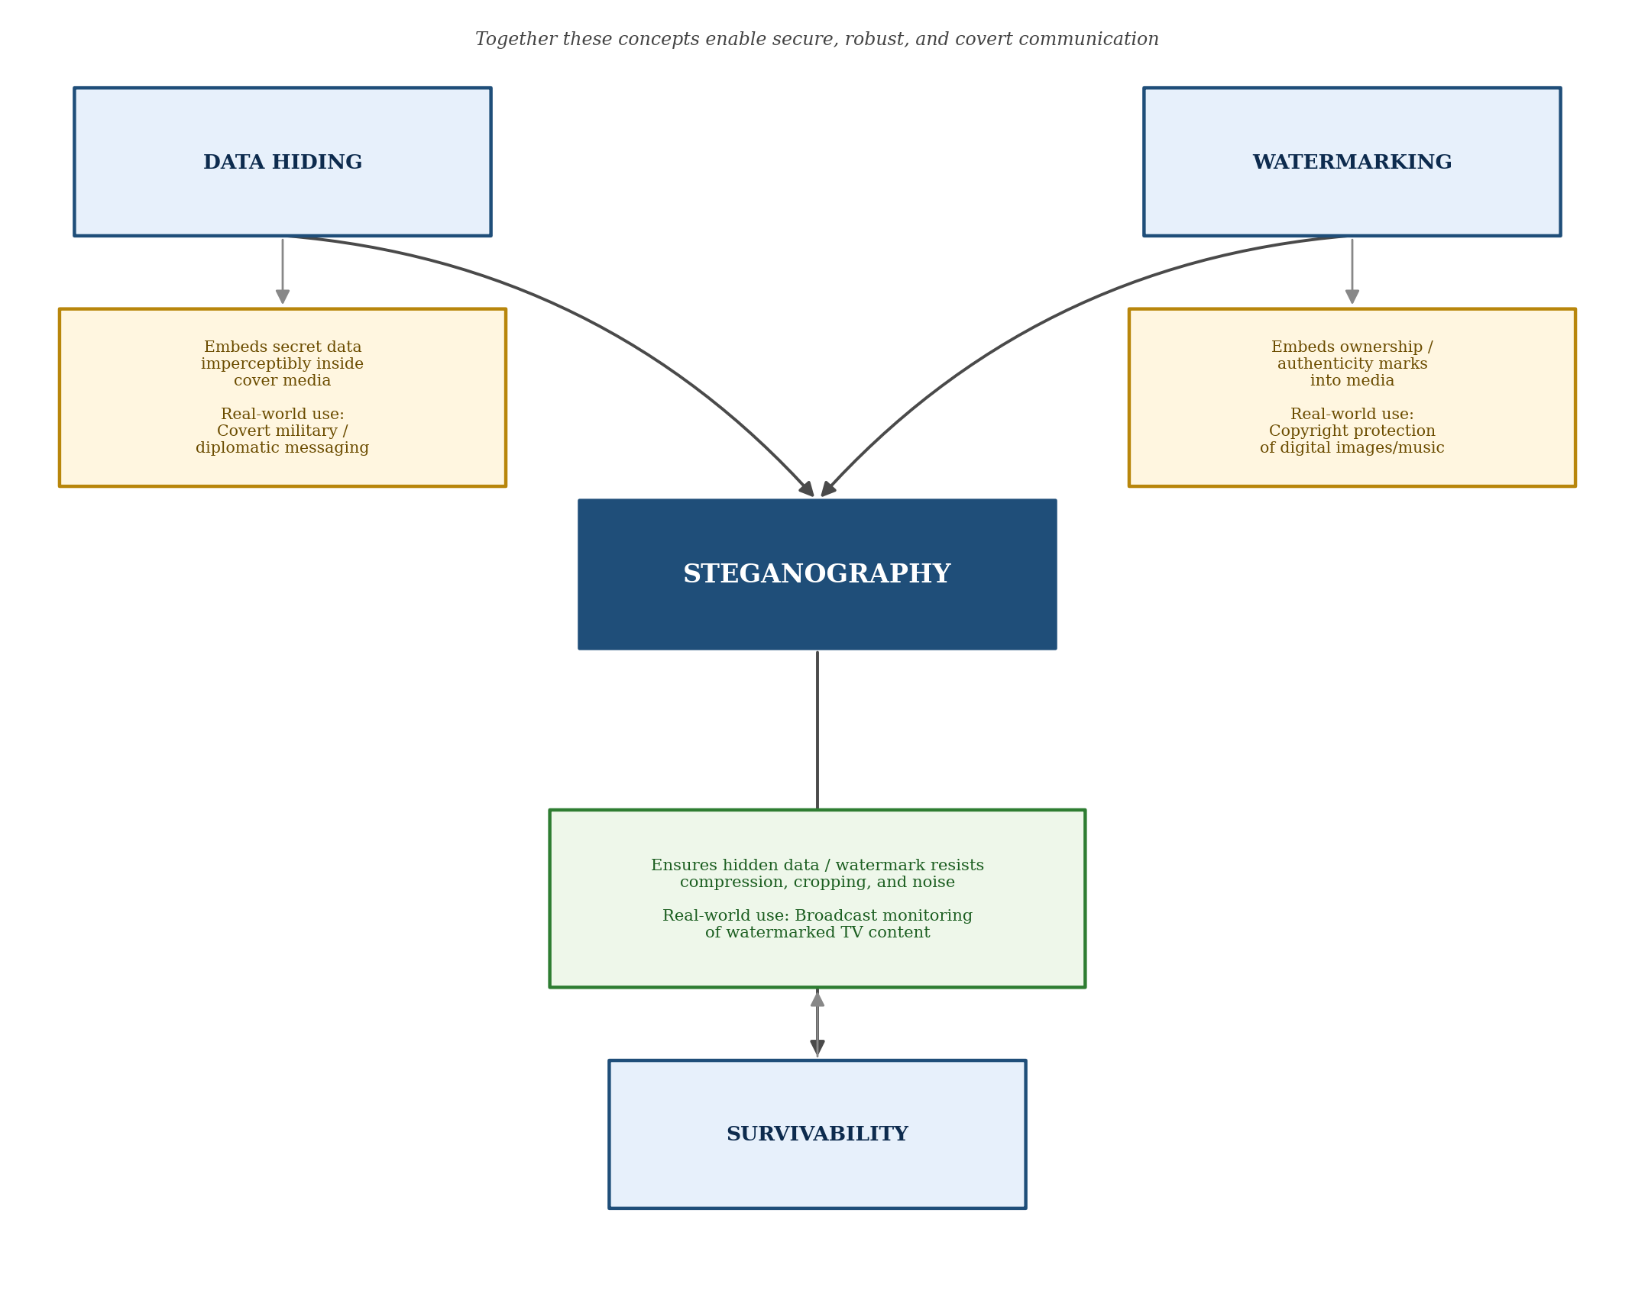

Explanation: Steganography is the umbrella science of hiding the very existence of a secret message inside an innocent-looking cover medium (image, audio, video or text). Data Hiding is the core mechanical technique used to embed that secret payload imperceptibly - for example, hiding a covert message inside the least significant bits of an image, which is widely used in covert military and diplomatic communication. Watermarking is a closely related application of data hiding that embeds ownership or authenticity information (rather than a secret message) into digital media, and is commonly used to protect the copyright of images, music and video. Survivability refers to how well the hidden data or watermark withstands processing operations such as compression, cropping, filtering and noise; broadcast monitoring systems rely on watermark survivability to automatically detect when and where watermarked television content is aired. Together, data hiding provides the mechanism, watermarking provides one major real-world application of that mechanism, and survivability determines whether the hidden information remains usable after the cover medium is transmitted or altered - making all three essential to secure, robust covert communication.

Question 5: Number Theory Concepts in Cryptography

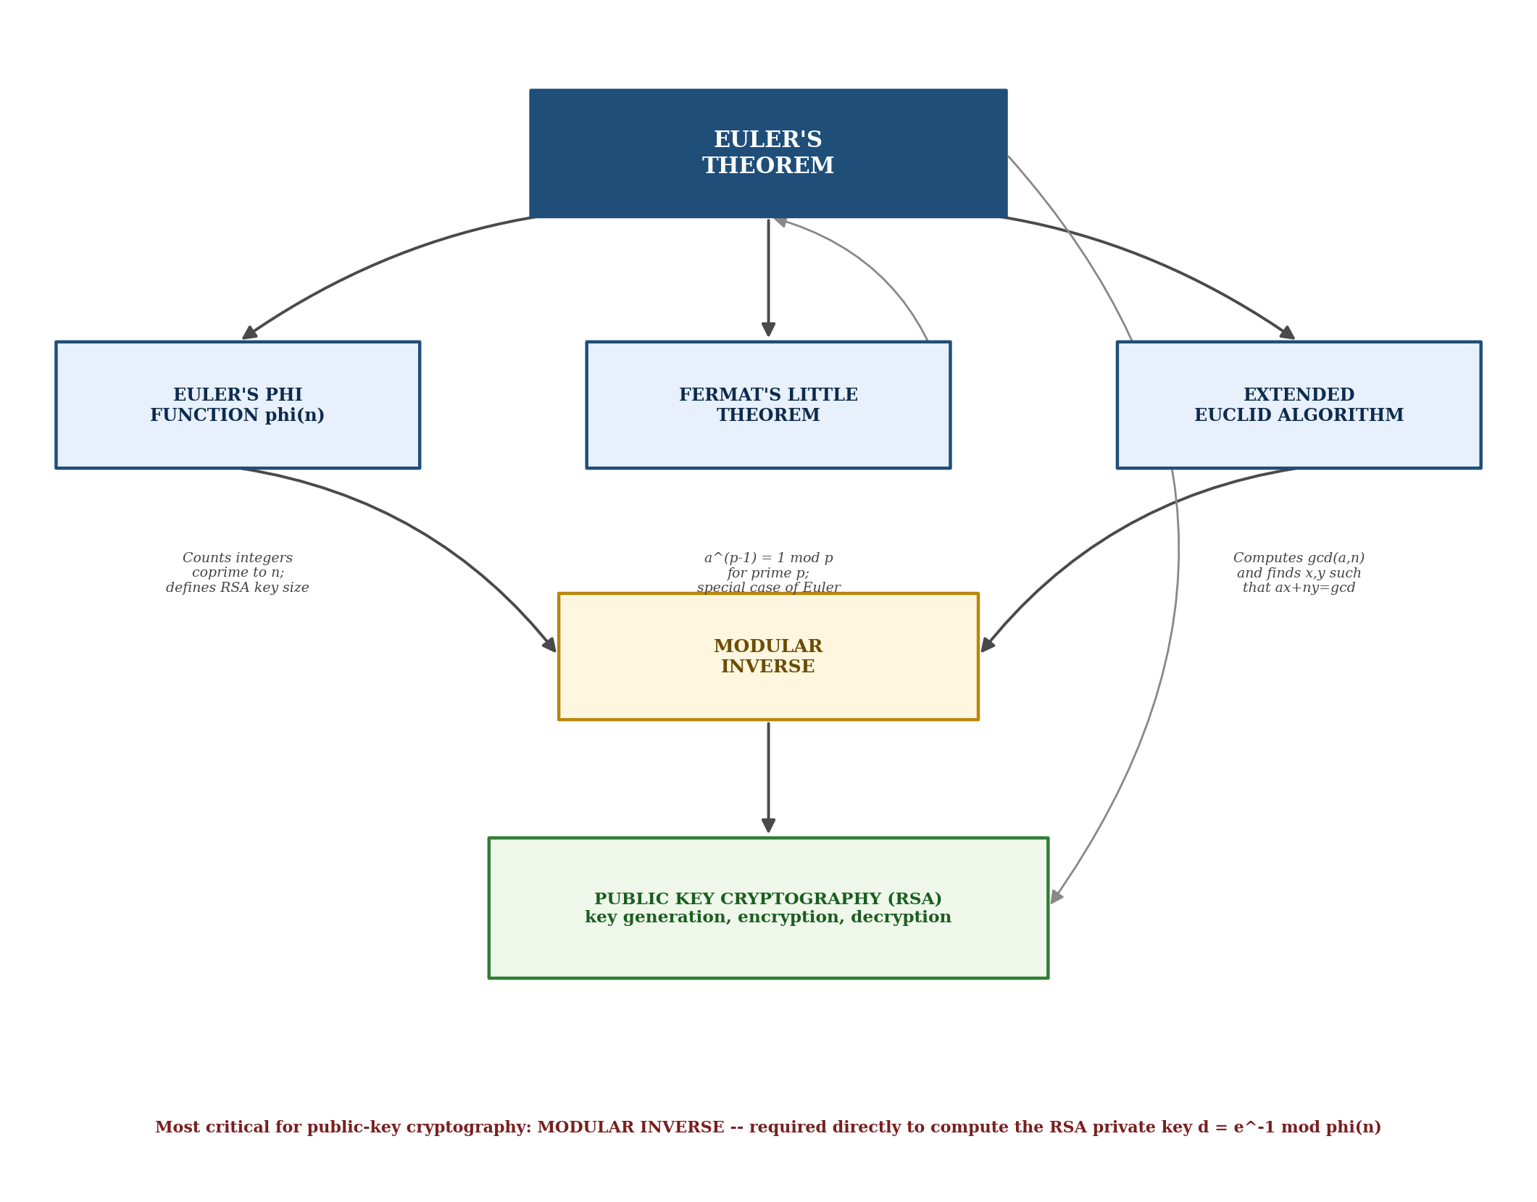

Explanation: These five number-theory concepts are mathematically interlinked and together underpin public-key cryptosystems such as RSA. Euler's Phi Function, phi(n), counts the positive integers up to n that are coprime to n, and directly determines the size of the key space used in RSA key generation. Euler's Theorem generalises this idea, stating that a raised to phi(n) is congruent to 1 mod n for any a coprime to n; when n is a prime number p, this reduces to the special case known as Fermat's Little Theorem (a to the power p-1 = 1 mod p). The Extended Euclidean Algorithm computes the greatest common divisor of two integers while simultaneously finding integer coefficients x and y such that ax + ny = gcd(a,n); when gcd(a,n) = 1, this same computation yields the Modular Inverse of a modulo n. All of these concepts converge in RSA public-key cryptography: phi(n) sizes the keys, Euler's/Fermat's theorems guarantee that encryption and decryption are mathematical inverses of one another, and the modular inverse - obtained via the Extended Euclidean Algorithm - is used to compute the private exponent d from the public exponent e.

Analysis: The Modular Inverse is arguably the most critical concept for public-key cryptography in practice, because it is the concept directly computed and used during RSA key generation - the private key d is calculated as the modular inverse of the public exponent e modulo phi(n). Without an efficiently computable modular inverse (via the Extended Euclidean Algorithm), the entire RSA decryption process would not be possible, even though Euler's Theorem is what mathematically guarantees that the resulting keys work correctly.

RUBRICS FOR CALCULATION:

Criteria | Weightage | Level 4 – Exemplary | Level 3 – Proficient | Level 2 – Developing | Level 1 – Beginning
Understanding of Concepts | 25 | Demonstrates thorough understanding and effectively integrates multiple concepts/technologies | Good understanding with proper integration of most concepts | Basic understanding; limited or partial integration | Poor understanding; unable to integrate concepts
Experimental Design | 30 | Well-planned, systematic implementation with optimal solution | Correct implementation with minor issues | Basic implementation with errors or inefficiencies | Incorrect or incomplete implementation
Use of Tools | 20 | Effective and advanced use of tools/technologies with proper configuration | Appropriate use of tools with correct execution | Limited or inconsistent use of tools | Incorrect or minimal use of tools
Analysis of Results | 15 | Insightful analysis with accurate interpretation and validation of results | Good analysis with reasonable interpretation | Basic analysis with limited insights | Poor or incorrect analysis of results
Documentation | 10 | Clear, well-structured documentation with diagrams, code, and results | Organized documentation with necessary details | Basic documentation with missing details | Poor or incomplete documentation

